**CPS Faster Payment- Bank Holiday and next working day**

**Alpha Mackie**

**Software Developer Level 4**

Introduction

This task was verbally assigned to me by my lead developer to implement a functionality that checks for a bank holiday and the next working day to ensure that a claimant’s benefit payment date does not fall on a bank holiday.

First steps

I decided to build a custom activity using the C# programming language to accomplish this task. My reason for this option was to build a reusable activity and avoid writing long and messy code on Uipath.

Development process

I built two custom activities; one I named nextWorkingDay and the other, IsBankholiday using Visual Studio Code as the Integrated Development Environment (IDE). I then installed them as custom activities in UiPath to make them available for building the components. I also build a test harness for unit testing the components before they are integrated into the workflow, to ensure that they work successfully. Please see below the component with the two custom activities in it.

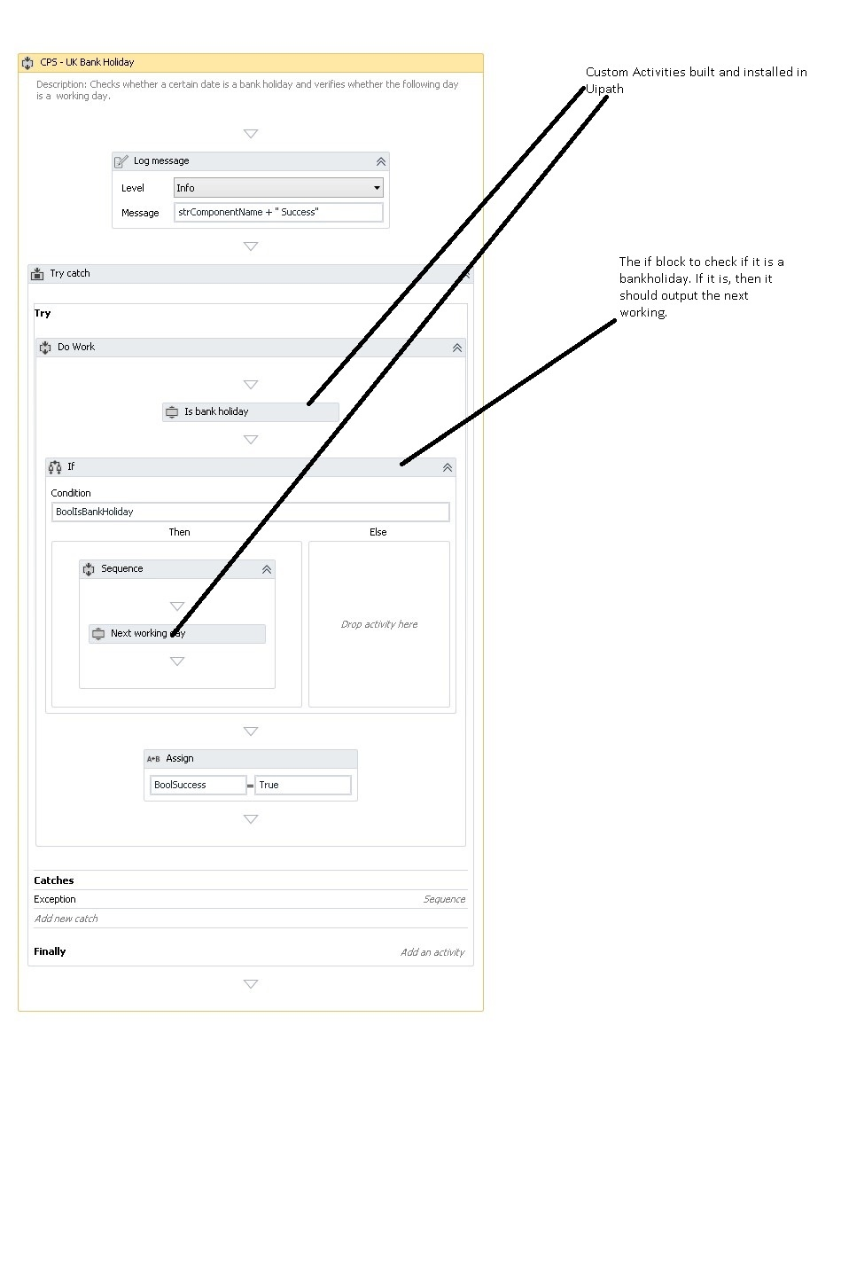

*Figure 1: Component to check if it is a bank and the next working day.*

The screenshot below of the C# code shows the Class IsBankholiday with the input and output arguments and the method that calculates the input date to determine whether it is a bank holiday.

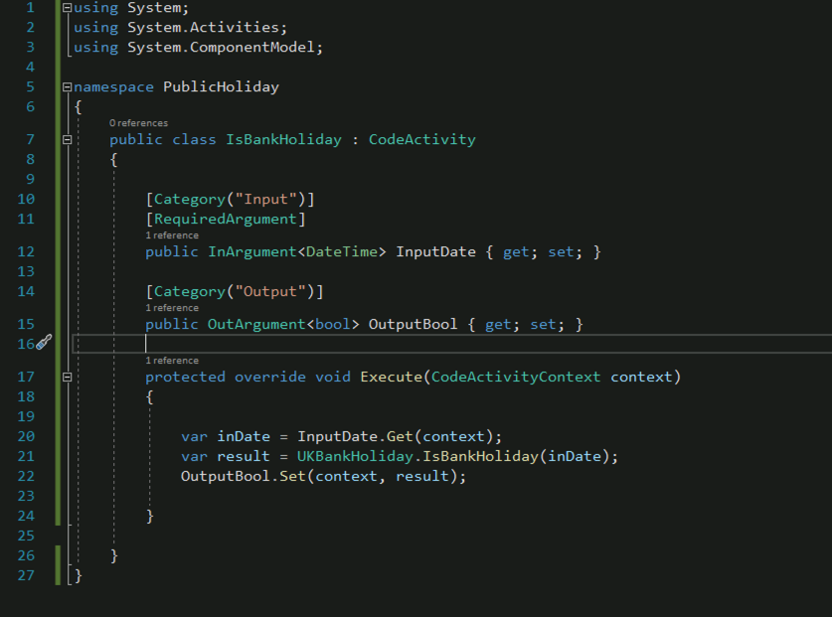

*Figure 2: C# code to check whether it is a bank holiday*

The next code snippet below checks for the next working if the input date is a bank holiday, seen below.

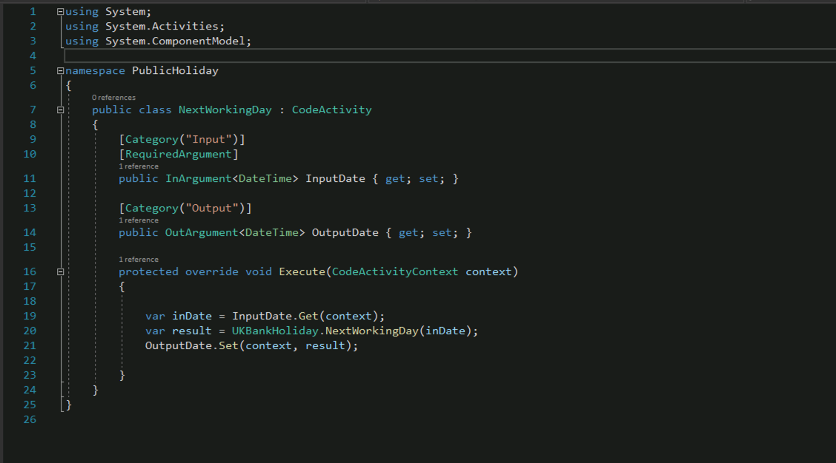

*Figure 3: C# code to determine the next working day.*

Test Harness

After building the component, I then performed the testing to ensure that I get the required output without any errors. Please see test harness below:

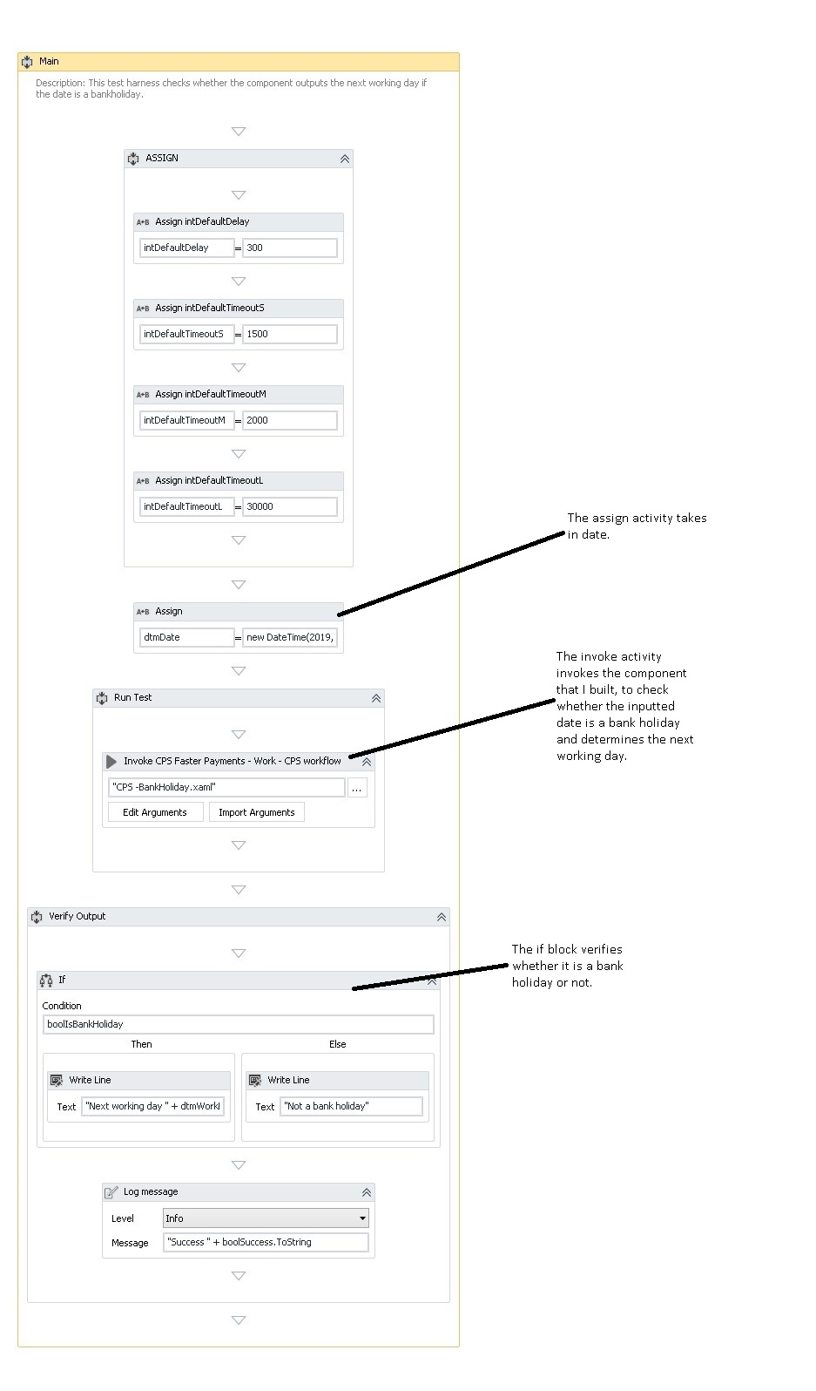

*Figure 4: Test harness to unit test the component*

In the output from the test harness below it shows when it is a bank holiday and the next working day:

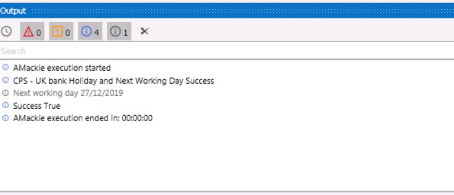

*Figure 5a: Test output showing bank holiday and next working day.*

The output below shows that the inputted date was not a bank holiday:

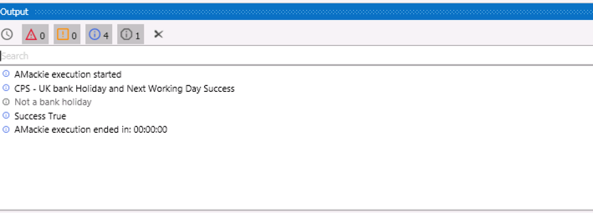

*Figure 5b: Test output showing that it is not a bank holiday.*

Final steps

The lead developer is then provided with the opportunity to check and confirm that it works. In this case he informed the Scrum master that the component works.

Conclusion

I found this particular task quite a complex one and needed to do some online research as well as consulting some of my more experienced colleagues, as I was a beginner learning the fundamentals of C#. The complexity for me is the fact that it takes into account all the Bankholidays and weekends. Payment should be made to claimants on a working day, if the payment date falls on a Bank holiday or on Good Friday, the payment should be made on an earlier date.  
I decided to build a custom Activity on C# which I installed in Uipath because the activity can be reused and also if it has a bug and doesn’t work, it can be isolated, removed or updated.  
The high point for me about this task is that after building the component, I tested it a few times and got successful outputs. It was reviewed by my senior Dev, who was happy with it.